Complex signal transmission

SCC 300 Final Year Project

Elliot Harrison

BSc Hons Computer Science (Full Time)

Submission: 31/03/2017

**Table of Contents**

Chapter 1: Introduction

Chapter 2: Background on Wireless Communication

2.1 Single Antenna Wireless Communication

2.2 Multiple input Multiple output

2.3 Antenna Diversity

2.4 Antenna Diversity Combining

2.5 Channel access methods

2.6 Fading

2.7 Space-Time Coding

2.8 Summary of background

Chapter 3: Design

3.1 MIMO system architecture

3.2 Summary of design

Chapter 4: Implementation and Evaluation

4.1 Single input and output antenna simulation

4.2 Multi-antenna simulation

4.3 Modulation multiple access simulation

4.4 Space-time coding simulation

4.6 Table of Terminology

4.7 Summary of implementation and evaluation

Chapter 5: Conclusion of future actions

**Chapter 1: Introduction**

For the ever-expanding data transfer demands of internet-protocol and voice communications that carrier networks are under each generative iteration. The research and practical application of the methods, of which to transfer and access this data is also in need of constant development and exploration. In this report, I will be discussing and rationalizing the past, current and future methods of signal transmission with and without antenna diversity and diversity combining at the receiver for error correction. I will also be exploring channel multiple access methods for increasing concurrent access of user’s and the coding method of space-time coding for best transmitter, configuration transmission of MIMO systems. These methods include and surrounded by:

* Single-Antenna transmission (SISO)
* Multiple Input Multiple Output (MIMO) system antennas
* Frequency Division Multiple Access (FDMA)
* Frequency Division Multiplexing (FDM)
* Time Division Multiple Access (TDMA)
* Time Division Multiplexing (TDM)
* Code Division Multiple Access (CDMA)
* Code Division Multiplexing (CDM)
* Orthogonal Frequency Division Multiple Access (OFDMA)
* Orthogonal Frequency Division Multiplexing (OFDM)
* Non-orthogonal Multiple Access (NOMA)
* Beamforming array combining
* Maximal Ratio Combining (MRC) and Equal Gain Combining (EGC)
* Space-time coding

I will be designing, implementing and evaluating the effectiveness of these methods and bit error rate over signal to noise when transmitting and combining received data, through MATHLAB program simulations of these methods.

Address for accessing projects, working documents web space:

www.lancaster.ac.uk/ug/harrisoe/Working Documents.zip

**Chapter 2: Background on Wireless Communication**

In this chapter, I will explore and rationalize the methods of transmission architecture, through single antenna transmission, its data capacity limit/reliability, and MIMO systems for smart diverse antenna configurations for an increase in data capacity and reliability. I will also be exploring the multiple access methods for these systems in the form of multiplexing a signals dimensions to increase concurrent streams for users. I will also be rationalizing the methods of diverse antenna signal combining for error correction at the receiver such as MRC (Maximal Ratio Combining) and EGC (Equal Gain Combining). Further on I will be discussing the coding method of Space-time coding to better learn the conditions of the transmission based upon the architecture of a MIMO/SISO system.

**2.1 Single Antenna Wireless Communication**

Methods of communication that require diverse antenna are becoming increasingly in demand, as the network quota of internet-protocol/voice communication data vastly expands. Historically the method of transmission/reception would be defined between a single antenna at either end of the communication, providing the basis of simple sending and receiving of signal data between the two mediums. This configuration however, is limited by the spectral efficiency limitations of a standard single Tx, Rx configuration, and is affected largely by natural interferences because of a lack of diverse antenna.



Figure 1 Single Channel Transmission

This single channel configuration of communication can be defined with the function:

***Y = f (x)***

***= h.x + n***

*Denoted by:*

*h (attenuation), n (noise), f (function prefix), x (observation).*

The theoretical bandwidth limit of single channel/antenna transmission, can be defined through the Shannon-Hartley theorem:

***C = B log2 (1 + S/N)***

*Denoted by:*

*C (Channel limit), B (Bandwidth), S (Received signal power average), N (power of noise & interference), S/N (Signal over noise ratio).*

This single channel data spectrum limit, natural interferences from signal reflection and a lack of antenna diversity, are the main obstacles for communication in a modern internet-protocol/voice communicative centered public domain.

Signal transmission through a single antenna configuration at either end of communication, is affected by the main natural variables of, capacity limits of bandwidth/spectrum from a given transmission, delay, co-interference and multi-pathing.

Additive White Gaussian Noise (AWGN) is a natural noise additive utilized for simulations and theories in information processing through AWGN channels, to represent background noise from radiation along the path that a signal propagates [1][1]. Thermal noise, radiation are example producers of natural noise in wideband transmission [1]. The channel capacity of an AWGN channel of normal distribution can be defined through:

***C = ½ log (1 + P/N)***

*Denoted by:*

*C (channel capacity), P/N (Signal over noise)*

**2.2 Multiple input Multiple output**

To rationalize and explore multiple access models, we must define the theoretical limit of multi-antenna transmission, the theoretical maximum data transfer limit that one cannot exceed through multi-antenna transmission of a specified bandwidth is ascertained through logarithm:

***log2 (t P.s.|h|2 / Pn)***

***Ps / Pn = SnR = P***

***= G2 (t |p| |h|2) bits/Hz/seconds***

***B.log2 ( |tp| |h|2) bits/s***

*Denoted by:*

*B (Bandwidth), h (Channel capacity), SnR (Signal to noise ratio), t (Time), s (Signal), n (Noise), |t| (Absolute value of t), |p| (Absolute value of p), G (Observation value), |h| (Absolute time of channel transmission).*

Multiple input Multiple output (MIMO), is the method of implementing multiple transmitter and receiver antennas, to provide an overall better quality and reliable service through what is effectively redundant data, that the receiver can combine to acquire better quality uplink/downlink transmission to an increasing number of recipients. the main motivations are to increase the spectral efficiency and capacity of communication channels, to send larger amounts of data through a given transmission.

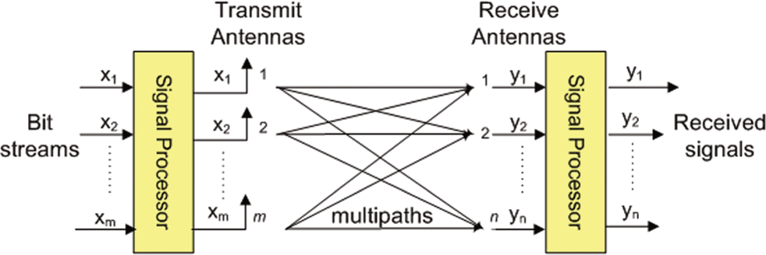

[2]Figure 2 Multi antenna transmitter to multiple reception antenna

Example of transmission of multi-smart antenna diversity can be defined through:

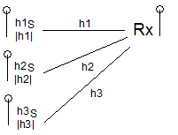

Figure 3 Multi EGC MISO system antenna transmission

*Where Rx receiver output is observed as Y:*

***Y = h1. (h1S/|h1|) + h2. (h2S/|h2) + n***

***= |h1|2 S / |h1| + |h2|2/|h2| S + n***

***= |h1|S + |h2|S + n***

***= (|h1| + |h2|) S + n***

*Y(observation), h1, h2, h3(coefficients/antenna), |h| (Absolute time of channel transmission).*

To overcome spectral limitations of a single antenna transmission, one must concurrently transmit multiple modulated signals across several antennas, observe the natural effects and error correct at the receiver to summarize the information from transceiver to acquire the correct/best case output signal. This method allows the transmitter [3] to send a greater amount of reliable data in a single transmission and increase spectral efficiency in combination with multiple access modulative techniques. In relation to what Manar Mohaisen et al states, [3][3] *"In communication systems, we have to increase the reliability of the communication operation between transmitter and receiver while maintaining a high spectral efficiency. The ultimate solution relies in the use of diversity, which can be viewed as a form of redundancy " -*. Diversity is a branch key component of MIMO Transmission Systems and exploits the use of, Spatial Diversity, Time Diversity and Frequency Diversity. Through this antenna diversity the receiver must also Diversity combine to error correct the data.

**2.3 Antenna Diversity**

Since a signal can take multiple reflected paths before being received, there are variables to consider such as noise, signal attenuation, fading, distortions known as multi-pathing or reflections.

Spatial diversity is implemented, to correct the reliability of a channel and is used primarily as the uplink method for data [4]. Spatial Multiplexing increases the capacity of the channel. Moreover, Spatial diversity implements the method of transmitting several differently encoded signals from multiple antenna, that are affected differently by natural phenomena [4]. In doing this the receiver can error correct multipathing, by observing and correcting based off these differences in signal diversity, increasing the reliability of the signal received. Spatial Multiplexing focuses on sending multiple streams of data through these spatial diverse channels [4].

Spatial diverse channels can be defined through:

***A8 = min (At, Ar)***

*Denoted by:*

*transmitter is made up of At antenna, Receiver is made up of Ar antenna.*

*A8 is the number of streams that can be sent in analogous which is based on a linear receiver and depending on degrees of freedom will define the channel capacity* [4]. *Equivalently providing the ability to send 8*bits/second per Hz (frequency band), across the multiple antenna providing a greater data capacity/reliability and redundancy* [4][4].

Time diversity is the method of which counteracts errors, spawned from time constraints, introducing excessive fading of the signal in transmission, resulted from diverse transmission. Which can be caused by variables, symbol interference spread across time/electromagnetic interference, movement of the receiver/transmitter. In which are error corrected by repeated data at the transmitter, sent multiple times, or by applying an error correcting bit to the payload via bit interleaving [5][5]. This is known as Forward error correction (FEC).

Forward error correction (FEC), is focused on correcting unreliable channels transmitting a signal on a distorted path, by providing redundant bit encoding into a message to counteract the natural electromagnetic interference/noise on transit [6][6].

The fundamental method of forward correction is the transmitting of a triplet stream of bits, consecutively, namely repetitive code [6]. This stream of bits for correction, is an original copied section of the data defined through a function and sent from the transmitter. This method is limited and simple providing basic redundancy, as there is limited bit code correction to the triplet because of the chance, that the error affected original word exceeds it [6]. If this is the case, then the corrupted data cannot be recovered. Bit interleaving is a method for reducing this outcome.

Bit interleaving is a method of supporting the limitation of repetitive code, in the scenario of which burst errors occur in a data stream [6]. It does this through shifting bits in the original word, to provide the repetitive code error check, with the need to only require a bit of the triplet it sends [6]. To increase reliability of receiving an interpretable/usable section of the code across multiple unreliable transmissions.

Frequency diversity is the method of which looks to correct the effects of time diversity on a given signal [7][7]. Particularly delay in transmission, via the method of hopping frequency bands and transmitting repeated data on multiple frequency channels, to increase overall spectrum utilization [7]. But sacrifices multi-antenna technology to send on frequency bands at separate times, rather than a simultaneous transmission across an array of diverse antenna and is affected by frequency-selective fading in transmission. This fact has the subsequent loss of diversity among signals and decreases the range of multipathing error correction, at the receiver end [7].

**2.4 Antenna Diversity Combining**

Diversity Combining is a method of collecting multiple spatial diverse signals reception, into one single signal to improve the quality of the signal and is used primarily as the downlink for data at the receiver end [8][8], after analysis of natural phenomena/interferences have affected the multiple signals differently such as attenuation, noise, distortion from reflection. It is also implemented to combat fading of a signal [8].

Beamforming is a technique pertaining to array gain in diversity, which is widely used by many sectors of application, which makes use of sensor array's [9][9]. this transmitting technique propagates a signal directly, by means of an array of antenna in which each transmitted phase and amplitude altered wave front from each antenna, superpose together in a direction to form a beam which in turn decreases radiation effect on the signal in transmission and a subsequent increase in reliability [9]. This in turn provides a stronger spatial diversity combination between signals when received and wider range of error data to utilize for combining.

Maximal-ratio combining and Equal-gain combining are related to reducing system error output through data processing and correction of noise of antenna diversity technique transmissions at the receiver end, this is due to inherent receiver imperfections [10][10]. The coefficients (h1, h2) channel errors are not assumed to be estimated perfectly without this diversity analysis and combination.

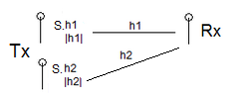

Figure 4 MRC antenna coefficients example

*Can be defined through observation:*

***Y1 = h1S + h1S + n***

***= (h1 + h1) S+n***

***Y1/h1+h2 = S***

***Y2 = (h12+ h22) S+n***

***Y2/(h12+h22)***

***Y2 = h1.h1/|h1|. S+n***

***H2 h2/|h2| S+n = (|h1|+|h2|) S+n***

***Denoted by:***

*Y1, Y2(observations), h1, h2(channels), S(signal), n(noise).*

MRC antenna receives a given diversity of signals and sums the diversity based on the best SNR of each signal received. Whilst EGC, based on the phase difference constant of the signals, will coherently sum the signals without taking the diverse array of signal factors into account, and without any amplitude level implications [10]. EGC is a basic method of combining as estimation of an amplitude of the channel isn't required but this subsequently limits its combining specification. MRC is a primary method of diversity combining in beamforming and large antenna array's. I will be implementing these methods and describing further in the design and implementation section of this report.

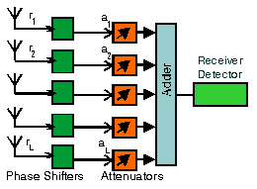

[11]Figure 5 MRC antenna combining configuration

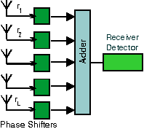

[12]Figure 6 EGC antenna combining configuration

**2.5 Channel access methods**

Based off corresponding methods of multiplexing, multiple access methods of a channel provide the receiving device, to access a multi-terminal transmitting medium which functions to share resources/services to a multitude of users.

Methods of multi-channel access serving, aimed at multiple users at a specified bandwidth via access terminals or devices, begin with Frequency-division multiple access (FDMA), which is a Multiple access technique possible through Frequency-division multiplexing. In which modulation of signals facilitate multiple frequency bands to each of the individual streams. From this modulation [13], FDMA allocates a transmitting/receiving medium, to a given stream or device [13][13]. A fundamental practical application was practiced in the 1st generation of communication in which a message sent by a cellular-device is allocated a frequency channel for download/upload of data. To maximize spectral efficiency using FDMA, one must filter and control frequencies effectively [13].

This vastly increases the real estate of data that can be accessed by multiple users across varying data frequency bands, but primarily implemented in voice communication due to this form of multiple access still having a limitation on bandwidth allocation, as it is split to serve the frequent access.

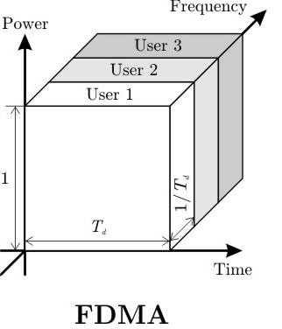

[14]Figure 7 Frequency-division multiple access

*Multiple users accessing from modulated bands on the frequency dimension of a signal.*

Making use of the Time Division Multiplexing (TDM) modulation method to split frequency bands by their place in the time domain, The Time Division Multiple Access (TDMA) method allocates time slots to data access for transmitting/receiving, on a device with a corresponding frequency band [15][15]. The channels are split into three time divisions to maximize channel usage and further increase capacity of the channels. To maximize spectral efficiency the transmitter must control the timings of frequency [15].

The lower and upper bound data limit of TDMA is substantial over FDMA transferring/receiving a cap limit of 64kbps – 120mbs over single transmission [15], primarily used for both voice and internet-protocol data transfer made possible by the time slot allocating maximum available bandwidth per terminal [15]. TDMA is primarily implemented in 2nd generation data networks in combination with FDMA.

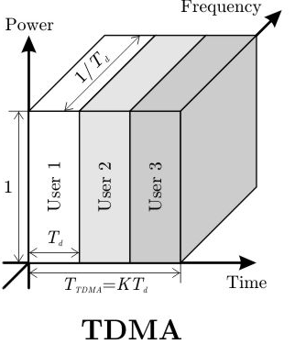

[16]Figure 8 Time-division multiple access

*Multiple users accessing from modulated slots on the time dimension of a signal.*

Code-division multiple access (CDMA) focuses on providing multi-terminal access for users on modulated power divisions of the signal. In which the bandwidth and all data is spread to provide multi-access divisions on different frequencies bands via the equivalent transmitted power across the frequencies, namely spread-spectrum [17][17]. The individual messages are sent with a unique code simultaneously interleaved, which at the receiver, the signal is divided out back into the ordered uniformed messages [17]. To maximize spectral efficiency one must control power levels effectively, as this is the main challenge that faces multi-access using CDMA. CDMA, TDMA and FDMA, effectively have the same spectral efficiency but modulate on different dimensions of the signal [17].

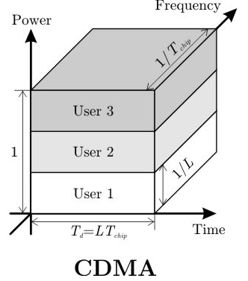

[18]Figure 9 Code-division multiple access

*Multiple users accessing from modulated slots on the code dimension of a signal.*

Primary channel access techniques, defined within a 3rd Generation data network implement Orthogonal Frequency Division Multiplexing (OFDM), to encode on separate frequency bands and modulating several parallel sub-carrier frequency-flat signals [19][19]. To effectively use the same bandwidth as single carrier modulation methods, saving a vast amount of bandwidth per service and increasing the spectral efficiency that multi-channel, air interface transmissions can provide per user [19].

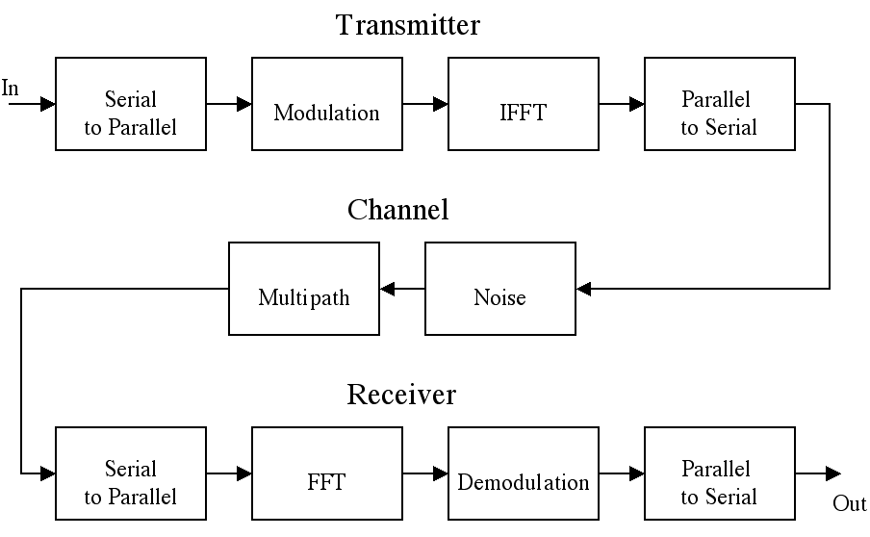

[20]Figure 10 Multiplexing model of OFDM before and after IFFT transformation

Iterating on and applying this modulation technology, in a marriage with Frequency-division multiple access (FDMA), in the 3G/4G LTE generations to provide Orthogonal Frequency Division Multiple Access (OFDMA) to an increase of multiple terminals across the time/frequency and code dimensions [21][21]. This is done through, modulating on multiple carrier frequency-flat frequencies of a signal, namely wideband. Primarily implemented widely in wireless, digital communication due the larger bandwidth/data rate available [21]. This addresses the inherent issues with fast fading and interference, from the OFDM scheme pertaining to narrow-band transmission [21]. The issue with OFDMA, is that spectral efficiency is limited by the spectrum resources that can be allocated to users who have low quality channel conditions utilizing the bandwidth, affecting availability of resources for those with better quality channel conditions [23].

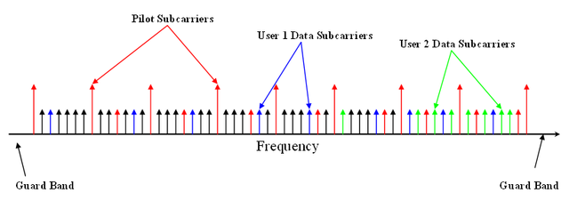

[22]Figure 11 OFDMA visualization of access subcarrier points

Current upcoming 3GPP generation technology of multiple access is focused on access on the time/frequency and code divisions of a signal across varying modulated power levels, this is known as NOMA, the more advanced method than OFDMA and the successor to the MUST system [23], NOMA provides a substantial increase in spectral efficiency across services to multiple user’s access on the modulated power dimension of the signal but with a power level differential, further widening the band/spectrum [23]. Zhiguo Ding et al state that [23][23] “*The key idea of NOMA is to use the power domain for multiple access, whereas the previous gener-ations of mobile networks have been relying on the time/frequency/code domain.”*

The key problem it tackles, is the spectral efficiency limitation from previous generation OMA systems and downlink MUST systems [23]. It provides an allocation of the power domain to a multitude of users, allowing those with low quality channel conditions to concurrently access sub carrier signals along with those with high quality channel conditions.

This method of multiple access serves the concurrent users across the same frequency, time and code domains but modulates on the power domain, with the quality of user channel conditions, deciding the level of power per user, if the channel is low quality then increase power for that user otherwise if the channel is high quality reduce power. The scheme of transmission is described by Zhiguo Ding et al that[24][24] *“the BS will send a superimposed mixture containing two messages for the two users, respectively.”.* Greatlyincreasing spectrum efficiency and allocation. The power between users is decided through cooperative methods of NOMA between the users, via the user with a better-quality channel uplink/downlink, must follow the SIC procedure to perform the low-quality channel users signal detection, as well as their own.

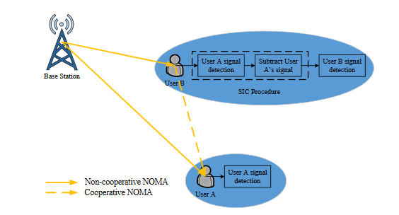

[25]Figure 12 two-user NOMA network example

NOMA systems and MIMO systems can be combined in methodology to greatly increase the channel capacity/redundancy and the spectral efficiency, but there is a tradeoff between these method benefits. These access methods naturally suffer a form of fading selectively to the dimension they modulate on.

**2.6 Fading**

Fading in signal transmission is a deep, fast or slow fading of a signal, caused from the effects of variables in time, frequency range, geographical positioning on a given signal or from a lack of diversity [26][26]. Because of the multipathing that a signal performs during its propagation namely reflectors, the receiver can perceive multiple superimposed signals each with varied affected properties such as phase, attenuation and delay, providing the environment that Spatial Diversity constructively benefits from [26]. But this also causes issues with interpreting the signal at the receiver end, due to interference, amplification, attenuation to the signal breaking the signal down to static random data, this possibility for destructive interference is known as deep fade [26].

Frequency-selective fading, of which we make the observation, can be defined using the following function:

***Y (x = h1.x(x) x.hx (t-1) th(x))***

*Denoted by:*

*y (observation), h1 (channel), t (time), x (signal condition variable)*

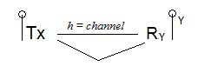

Figure 13 Frequency-selective channel

Is an occurrence of which a signal is separated, cancelling a part of the signal out and being received as the same signal that propagates differently to arrive at the same receiver [26]. This anomaly is usually caused by shifts in the ionosphere [26], causing and appearing as a gradual degradation of a signal [26].

Time-selective fading, of which we make the observation, can be defined using the following function:

***Y(t) = h.(t).x1t -1 h1 (t).x (t1)1***

*Denoted by:*

*y (observation), h1 (channel), t (time), x (signal condition variable)*

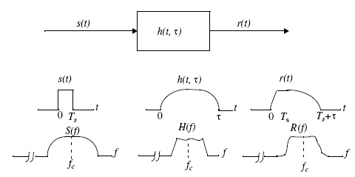

[27]Figure 14 Time-selective channels, Frequency-selective channels

Is the result of the fading and time variations or Doppler spread of a signal, selectively affecting the time domain. Which has the subsequent adverse effect, of breaking down the signals performance and efficiency. The solution to this is to modulate the signal effectively through the appropriate schema and code the data efficiently.

The Doppler effect can vastly reduce the performance of a channel, but can also be a benefit for increasing channel performance, if handled correctly. Doppler diversity is the aforementioned benefit of time selective channels which provides the possibility for higher performance and reliability with MIMO antenna transceiver systems.

An adopted method to effectively use Doppler spread to the channel's advantage, is to use a time frequency receiver at the receiver end to capture the spread of the diversity in the signal as its received or by implementing multi antennas to handle the diversity. Methods of reaching and interpreting a diverse Doppler spread on reception, include, to implement precoders at the transmitter or to multiplex the signal, namely Doppler Domain Multiplexing. N. Wei et al state that the upside of time selective channels is that [28][28]*"On the other hand, time-selective Channels provide Doppler diversity, so the maximum Diversity for multiple-input and multiple-output (MIMO) systems Over time-selective channels is N, N, (Q + 1)".* This in relation to the proposed STD codes [28] as a coding technique to be utilized in combination of time-selective and MIMO architectures to make constructive use of Doppler spread.

Because the symbol energy of a signal, on a time selective channel are spread out in the time domain, Intersymbol interference is also an issue. Whereby the dispersive channels transmitting signals containing symbols, can interfere with each other in transit affecting accuracy and distortion of the signal, equalizing the channel at the receiver end, is a method to counteract this effect.

Frequency-flat channels, of which we make the observation, can be defined using the following method:

***Y(x) = h(x).x***

*Denoted by:*

*y (observation), h (channel), x (signal condition variable)*

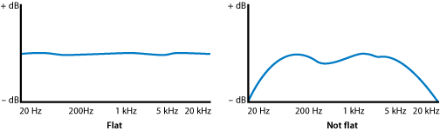

[29]Figure 15 Frequency-flat and not flat signal across a 20hz-20khz frequency band

Is an effect of which the bandwidth of the signal is slighter than the overall bandwidth coherence of the channel, subsequently applying an equivalent magnitude of fading to the entire frequency range of the signals components.

Methods of providing frequency diversity and providing support for fading, is to apply modulation schemes such as Orthogonal Frequency Division Multiplexing (OFDM), to provide a greater range of frequency bands for diversity spread using frequency-flat bandwidth frequencies.

**2.7 Space-time coding**

Space-time coding is a coding and modulation method, in smart antenna technology focused on overcoming the spectral limitations and reliability of transmission. Exploiting this technology is a key motivation in decreasing bandwidth/power usage and at the same time multiplying data rates [30]. Space-time coding at the transmitter provides a time slot domain mapping of the signals across space in time and then receives the signal based on the configuration/modulation and signaling strategy of the transmitter these processes are handled through S-T Modem's [30] at either end of the transaction. Sumeet Sandhu et al state that [30][30]"*The space-time (S-T) modem at the transmitter (Tx) encodes and modulates the information bits to be conveyed to the receiver and maps the signals to be transmitted across space (Mt transmit antennas) and time".* Regarding the S-T Modem’s as processing encoding/decoding at either end of transmission.

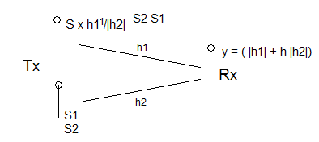

Figure 16 Space-time coding illustration

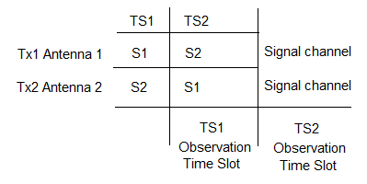

Figure 17 S-T Antenna/transmitter configuration

We make the following observations from this transmitter configuration of which, on first time send, we do not know the channel and transmission until its received based on transmission strategy in this case there is an antenna diversity of T2 antennas:

***TS1 Observation = y1 = h1 x S1 + h2 x S2 + h1***

***TS2 Observation = y2 = h1.S2 – h1.S1 + h2***

***Y1 = h1.S1 + h2.S2 + h1***

***Y2 = h1.S2 + h2.S1 + h2***

*Denoted b*y:

*Y1, Y2(coding observations), h1, h2(channels), S1, S2(Time slots)*

Sumeet et al, state that in receiving the coded data[31][31]"*The S-T modem at the receiver (Rx) processes the signals received on each of the Mr receive anten-nas according to the transmitter’s signaling strategy and demodulates and decodes the received signal."*

MIMO does not require a definition of transmission strategy, but when receiving the signal, it is preferred that at the transmitter information is known about the configuration [30] to improve performance with MIMO antenna technologies [30]. This coding and modulation technique is a simple but powerful technology, as it variably processes signals based on architectures of MIMO antenna's transmission and its requirements for up/downlink. These requirements are defined as reliability of the channel, the data rate of the up/downlink and its range of data.

Spatial multiplexing gain provided through antenna diverse MIMO architecture, is a modulation technique related to S-T coding [30], to achieve a higher spectral efficiency in (Hz/secs), by transmitting multiple streams of data through diverse antenna in different spatial dimensions to improve data rate/throughput and reliability through a single transmission.

**2.8 Summary of background**

In this chapter I covered the lack of diversity in a single antenna transmission and its spectral limitations/bandwidth, as well as MIMO systems utilizing multiple smart antenna diversity and combining the diversity at the receiver end with its conditions. The conditions I explored as fading and coefficient natural interference. I also explored multiple access methods through signal modulation on differing signal dimensions. I found that the increase of antenna diversity has its benefits for spectral efficiency/bandwidth but when received it requires large processing for combining the data of multiple antenna’s transmitting multiple signals. In the next chapter I will go onto the design of the MIMO System and its architecture. I also found that the current NOMA multiple access technology addresses the major problems with orthogonal access in user selection bias.

**Chapter 3: Design**

In this chapter I will be exploring the architectural configuration of a MIMO system, through the coding and smart antenna diverse techniques to increase spectral efficiency, channel reliability/capacity and link quality through transmission of this systems configuration.

**3.1 MIMO System architecture**

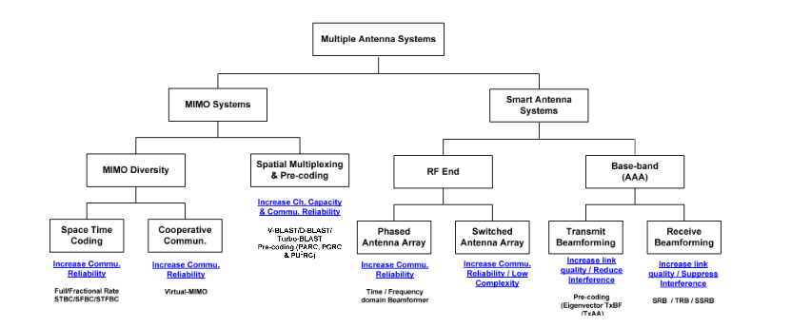

[32]Figure 18 Multiple Antenna System architectural diagram

The above architectural figure denotes Multiple Antenna Systems in communication, to two key schools of implementation, MIMO Systems and Smart Antenna Systems. It is the specification of the multiple schools of one Multiple Antenna System.

This overall scheme of design is the blueprint for my implementation of these systems and provide the specifications to evaluate so. Previously covered in background, MIMO Systems practice a diverse array of coding and modulation techniques, to increase the capacity of data channels, multiple access ability and reliability/coding techniques for sending information about to know more about the transmission and its condition, known as MIMO Diversity. It is focused on increasing reliability in communication, utilizing Space-Time Coding through processing, encoding/decoding, a signal based around the overall architectural design of the transmitter via S-T Time Codes, its uplink/downlink specifications and the signals conditions through multi-pathing. It is a simple but powerful coding technique and is the focus for my coding implementation.

Spatial Multiplexing is another MIMO System component, which is a form of multiple modulation techniques previously discussed and provides an increase for channel capacity/bandwidth for the multiple access methods, to take advantage over a spatially modulated signal. Pre-coding is the method of gaining, best condition transmission for a signal with minimal noise/interference via sending coded data to the receiver, to determine stream quality and reliability in the transceivers current specifications.

Smart Antenna Systems is a space-domain technique, focused on methods of transmission through multi-antenna array. Implementing a diverse array of antenna to decrease complexity, communicative reliability, reducing interference on a signal and the link quality of a channel. This is done through RF End, representing multi-antenna diversity and Base-band, representing diversity combination. Phased Antenna Array is a practice of RF End diversity, using phase shifted antenna elements to direct multiple signals in different directions to minimize or increase depending on the direction, its path and the destructive interference. But can be constructive interference, through handling this technique properly and subsequently increasing channel reliability.

A Switched Antenna Array is a form of antenna diversity in this architecture, which implements an array of fixed beam paths for the diverse antenna, which at a calculated point in time, one of these beams is transmitted based on the best-case system requirement. This reduces signal complexity through switching the beam that is transmitted. The reliability of the channel is fortified as it is a best vector path calculated beam forming system, with decreased radiation at a variable time, reducing the possibility of interference/noise.

Transmit Beamforming is the method of implementing pre-coding techniques through an Eigen Vector path, which provides a scalar replicative multiple of itself, to provide best case transmission specifications of the transmitter when the stream quality of the coded data is received. This increases the quality of the up/downlink of the channel and reduces the interference on the signal along its path, focused through the time domain. Receive Beamforming is the method of receiving and analyzing the gain of a beam formed transmission to acquire the spectral/power efficiency of the signal. Previously mentioned, MRC (Maximal Ratio Combining) is an example method in receiving beamformed transmission to combine the directivity and diversity of noise and interfered data, to correct the signal through proportionate constants between the noise level and the signal level of a given channel. Effectively suppressing interference and having the ability to correct the signal back to its original data form, subsequently increasing quality of the link.

**3.2 Summary of design**

In this chapter I described the MIMO system architecture components and their relation in the improvement of signal transmission methods. These components observe and formulate an improvement in spectral efficiency, channel capacity, link quality and reliability of a channel and signal. This is the architectural overview of the multi classed system I have implemented in the next chapter, within the MATHLAB IDE for effective mathematical data analysis of signal error estimates and observations.

**Chapter 4: Implementation and Evaluation**

In this chapter I will be focusing on recounting and rationalizing, the implementation of these methods of transmission and multiple access, through simulations in the MATHLAB program and evaluating results of errors made, estimates of channel data and summation of channel data from these simulation’s signal transmission conditions.

**4.1 SISO single antenna simulation**

The first design and implemented simulation, is of a SISO single antenna transmitter/receiver. Throughout the various simulation designs for single-multi carrier/antenna systems, we are focusing on the analysis of the semiology that is drawn from prior rough and evaluated estimates, random noise interference over the signal, an observation on the signal, the sum combination of observed data transmitted and the errors we made on the signal.

First program implementation basis:

Firstly, we create the 2-dimensional array data range for the signal to noise ratio by the following:

***Signal to noise range matrix = [0 10 20 30]***

Initialize a loop for the signal checks which is bound within the range of the signal to noise data previously defined:

***Loop k = 1: length of signal to noise matrix***

SnR is ten to the power of matrix length and loop which itself is divided by 10.

***Signal to noise ratio =10 ^ (signal to noise ratio matrix(loop)/10*)**

Initialize the first and second combination sum of the signal(s) received:

***Summarize 1, summarize 2***

Initialize transmitter configuration:

***Transmitter = range of signal modulation (1, 1, [-1 1])***

***H1 channel = random number between (1,1)***

***H2 channel = random number between (1,1)***

Random AWGN channel noise:

***Variable = random number between (1,1) / square-root of SNR (Signal to Noise Ratio)***

Formulate receiving observations on single antenna simulation:

***Y1 = h1 channel x signal + h2 channel x signal + noise***

***Y2 = h1 absolute value of channel x signal + h2 absolute value of channel x signal + nois*e**

Make prior estimates of the signal value at the receiver for first step of detection:

***Prior estimation 1 = y1/(h1 channel + h2 channel)***

***Prior estimation 2 = y2/(absolute value of h1 + h2)***

We do this to find the first rough estimation in first time detection of signal’s error rate over noise through transmission.

Second step of detection, refine the Estimates:

***Estimate 1 = sign (prior estimation 1)***

***Estimate 2 = sign (prior estimation 2)***

This is done to take the refined estimated values on the receiver to evaluate them through conditional inequality of an estimation value to a signal, to check and decide the errors made on the signal summation.

Conditional on estimate to signal value to check for errors made:

***If estimation 1 is not equal to signal then:***

***Summation 1 + 1***

***If estimation 2 is not equal to signal then:***

***Summation 2 + 1***

From this program basis, I then execute the processing of semiology trends of the summations made of errors on each of the method simulation cases. Two figures per task to compare simulation variations.

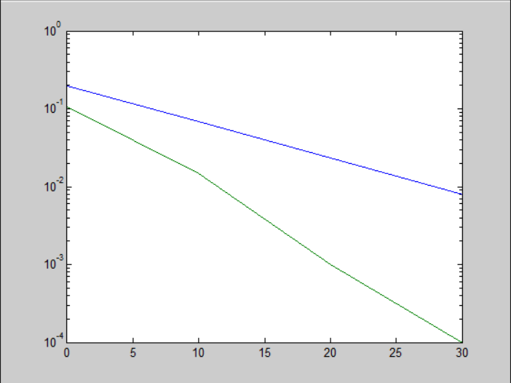

Figure 19 Single-antenna error semiology 1

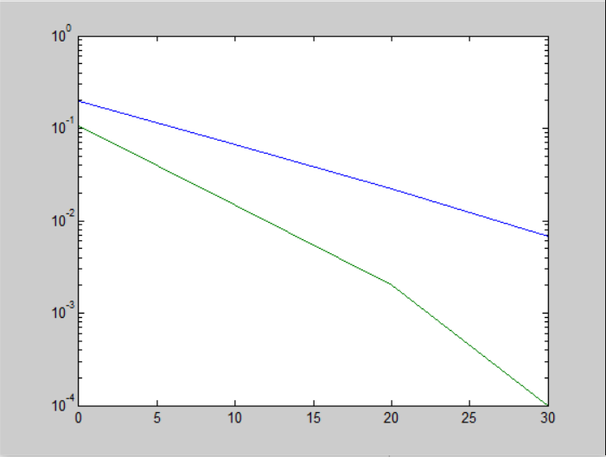

Figure 20 Single-antenna error semiology 2

The first task implementation, depicts multi-channel transmitter/receiver specifically a single transmitter/receiver antenna SISO configuration, with gradual interference increments of AWGN channel simulated noise over the signal transmission. With the goal of observing the estimate bit error ratio made/sec from the transmission of the signal through signal to noise in transmission. The Y-axis denotes bit error ratio over time frame. The X-axis denotes the signal to noise increments over 0-30 dBA (decibels) of amplitude and sound pressure. As depicted in the semiology the first line estimation shows a bit error ratio of 10 –0.8 or 0.1584/sec at the start of the trend, as AWGN noise increases the bit error ratio also gradually increases, in a steady trend as noise begins to affect the signal further. The second estimation depicts a steeper drop when reaching a signal to noise affected level of 20 dBA. Whilst the second trend, depicts a greater bit error rate of the channel than the beginning data error rate of the first estimation, and trends gradually along an equivalent path of interference but has a greater degradation before the estimate trend ends. Power is one at both ends in this case. The trends in this case suffer a standard error rate over noise interference and the errors made from this channel transmission is gradual over increments of noise affecting the signal and subsequent increments in error rate.

Key values recorded and evaluated of single antenna transmission simulation:

***Y1 observation value : –1.5422***

***Y2 observation value : –1.5422***

***H1 channel value : 0.5173***

***H2 channel value : 1.0251***

***Prior estimate : 1 –0.9999***

***Prior estimate : 2 –0.9999***

***Estimate 1 & 2 : –1***

***Summation value 1 : 66***

***Summation value 2 : 2***

**4.2 Multi-Antenna simulation**

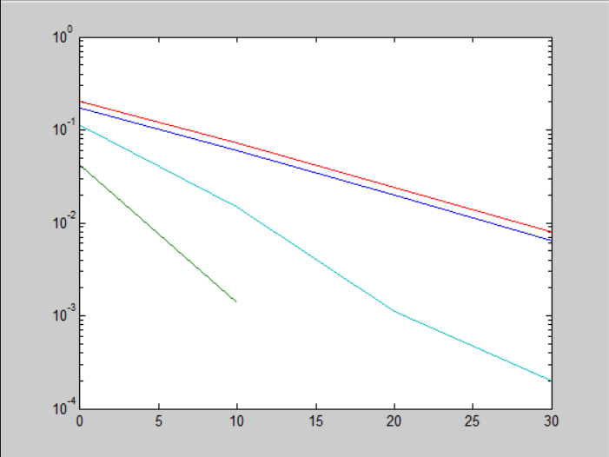

Figure 21 4-antenna error semiology

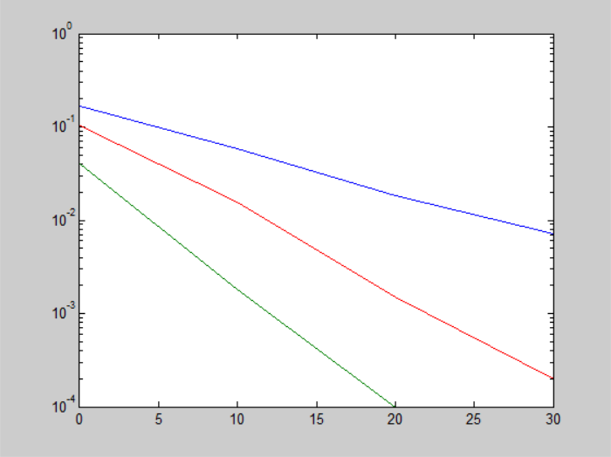

Figure 22 3-antenna error semiology

In this task, I simulated an environment of errors made and summation of estimates on channel data, where multiple diverse antennas are used in this case, 2-4 MRC and EGC antenna, of which I make estimations and observations from.

X-axis is denoted to signal to noise increments in dBA 0-30, Y-axis is denoted to bit error rate/sec.

The antenna array diversity of this case ranges through A2, A3, A4 concurrent streams where transmitter is made up of At antennas and the receiver is made up of Ar antennas, of data through single transmission specifying linear receiver adding transmitter complexity. With diverse antenna array's, multiple signals taking multi-paths provides a greater reliability from constructive interference and channel capacity when received, but the multitude of destructive errors made on these paths need to be corrected, which is why we simulate EGC (Equal-gain Combining) and MRC (Maximal Ratio Combining) antennas to combine antenna diverse data with error correction observations of destructive interference/Noise from AWGN channels. In what is known as array gain, smart antenna systems use MRC and EGC to combine the signals to increase power at the receiver and subsequently increasing signal quality.

What would be most effective in this case is MRC (Maximal Ratio Combining) antennas, this is inferred from results on the semiology in which, the first trend of estimate shows a data error rate of 100.9 or 7.943 Bits/sec to begin with and a gradual increase in error rate over ratio of signal to noise increments, in comparison to the two other estimate trends depicting a greater data error rate through noise through transmission. MRC sums the signals through absolute value transmitted based on best case of the SNR and takes further amplitude level consideration into account giving a more accurate output of original unaffected data than EGC. This simulation is also encompassing Beamforming in the case of receiving beamformed transmission of antenna array through diversity combination. EGC system takes basic channel data without amplitude level consideration for error correction and so isn't as widely practiced. Array gain ability at the receiver in MIMO systems is dependent on the number of transmit and receive antenna.

Write up observations made for variable MRC/EGC antenna cases:

***EGC Antenna x3 observation y3_1 : h1 * s + h2 * s + h3 * s + n***

***MRC Antenna x3 observation y3_2 : absolute value of (h1) * s + absolute value of (h2) * s + absolute value of (h3) * s + n***

***EGC Antenna x2 observation y2_1 : h1 * s + h2 * s + n***

***MRC Antenna x2 observation y2_2 : absolute value of (h1) * s + absolute value of (h2) * s + n***

***EGC Antenna x4 observation y4_1 : h1 * s + h2 * s + h3 * s + h4 * s + n***

***MRC Antenna x4 observation y4_2 : absolute value of (h1) * s + absolute value of (h2) * s + absolute value of (h3) * s + absolute value of (h4) * s + n***

*Denoted by:*

*H(channel), Sn(Signal and noise)*

First step of error detection for EGC and MRC antenna rough prior estimates:

***Prior estimation x3 antenna = y_EGC antenna 3 /(h1+h2+h3)***

***Prior estimation x3 antenna = y_MRC antenna 3 / (absolute value of (h1) + absolute value of (h2) + absolute value of (h3))***

***Prior estimation x2 antenna = y_EGC antenna 2 /(h1+h2)***

***Prior estimation x2 antenna = y_MRC antenna 2 / (absolute value of (h1) + absolute value of (h2))***

***Prior estimation x4 antenna = y_EGC antenna 4 /(h1+h2+h3+h4)***

***Prior estimation x4 antenna = y_MRC antenna 4 / (absolute value of (h1) + absolute value of (h2) + absolute value of (h3) + absolute value of (h4))***

Second step estimations for EGC and MRC antenna:

***Estimate 1-4 = sign (Prior estimation x3 antenna)* -** for each case of antenna diversity At, Ar.

Summarize errors made on the signal:

***If estimation 1 is not equal to signal at receiver, then:***

***Summation 1 + 1***

Key values recorded and evaluated from multiple antenna simulation:

***EGC Antenna x3 observation y3_1 value : -1.3092***

***MRC Antenna x3 observation y3_2 value : 1.984***

***EGC Antenna x2 observation y2_1 value : -0.3853***

***MRC Antenna x2 observation y2_2 value : 1.0244***

***EGC Antenna x4 observation y4_1 value : -1.8333***

***MRC Antenna x4 observation y4_2 value : 2.4725***

***H1 channel value : -0.7048***

***H2 channel value : 0.3008***

***Prior estimate value 1 : 0.9859***

***Prior estimate value 2 : 1.0097***

***Prior estimate value 3 : 0.9536***

***Prior estimate value 4 : 1.0186***

***Estimate 1, 2, 3, 4 value : 1***

***Summation value 1 : 66***

***Summation value 2 : 0***

***Summation value 3 : 70***

***Summation value 4 : 3***

**4.3 Modulation multiple access error simulation**

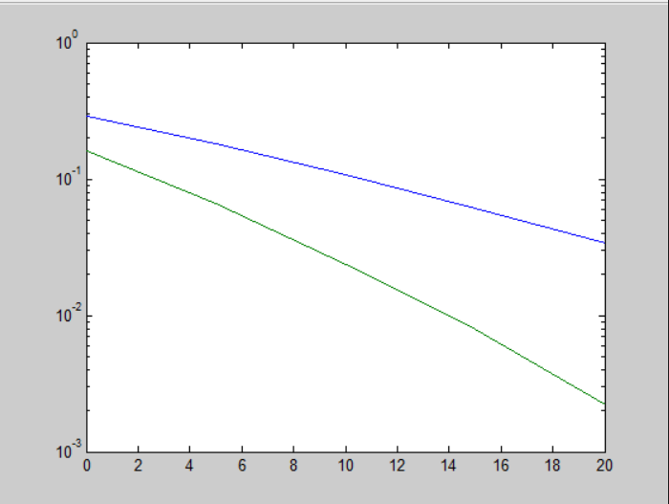

Figure 23 Modulation error semiology 1

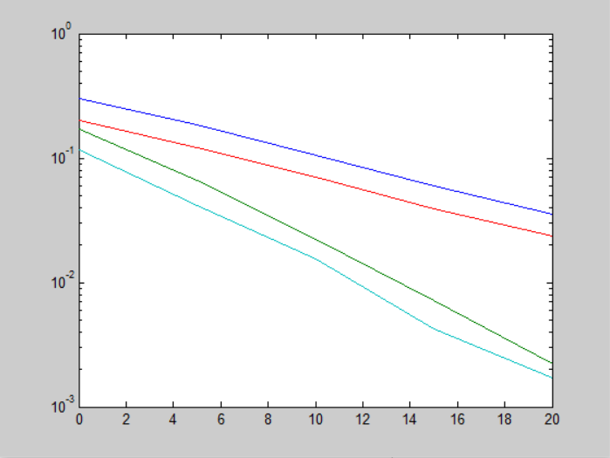

Figure 24 Modulated signal error semiology 2

In this task, I focused on the method of modulating along a signals dimension to increase the range of multiple access data streams per channel specifically 2-streams per channel of which are 2, then observe the errors made from doing so.

For this I defined the modulative range:

***Transmitter = range of signal modulation (1, 1, [3 1 – 1 -3])***

Using this array range I can simulate modulation of bandwidth frequency bands and the AWGN channel noise affect across the range on a signal, in comparison to the multi-antenna, MRC/EGC and single antenna simulations.

Depicted in the above semiology, I infer that the errors made through the estimates and rough prior estimates on the modulated channel, show a gradual increase of bit error rate over noise increments with the channel modulate estimates split in their trending. This shows the third and fourth estimation conditions dropping off, a steeper increase of error rate through the noise range over transmission in comparison to the first two estimate summations.

Check errors made on the signal on estimate data of transmission:

***If estimation 1 is not equal to signal at receiver, then:***

***Summation 1 + 1***

In this case of estimation, as well as checking the errors made, the program checks an equivalence of the value of the rough prior estimations made, to the modulate values which decides the refined estimations on the signal. This is conditionalized throughout the range -3 to 3, to simulate estimation of error rate throughout the frequency range at the transmitter/receiver, for a transmission architecture that modulates on channel data for multiple access capability.

***Estimation = y1/(Z) Sign y / (Z)***

***If Z > 2 then estimation = 3***

***Else if Z < 2 and Z > 0 then estimation = 1***

*Denoted by:*

*Z (Prior rough estimation), y (Sign)*

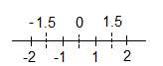

Figure 25 Modulation on signal data array

In this illustration of data modulation, the bandwidth frequency is divided into its modulates, to check estimates through the wider range and sub range of the frequencies.

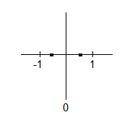

Figure 26 Non-modulated channel

This figure exemplifies the first simulations I rationalized, implementing signals without extensive modulation on its data, which were of the range -1 to 1.

Key values recorded and evaluated from the modulate simulation:

***Y1 observation value : –4.6820***

***Y2 observation value : –5.4963***

***H1 channel value : -0.1357***

***H2 channel value : 1.7054***

***Prior estimate : 1 –2.9828***

***Prior estimate : 2 –2.9853***

***Estimate 1 & 2 : -3, -3***

***Summation value 1 : 361***

***Summation value 2 : 24***

**4.4 Space-Time coding simulation**

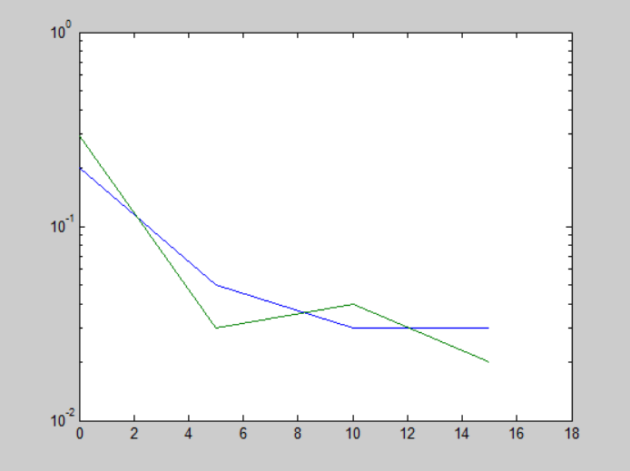

Figure 27 Space-Time coding semiology 1

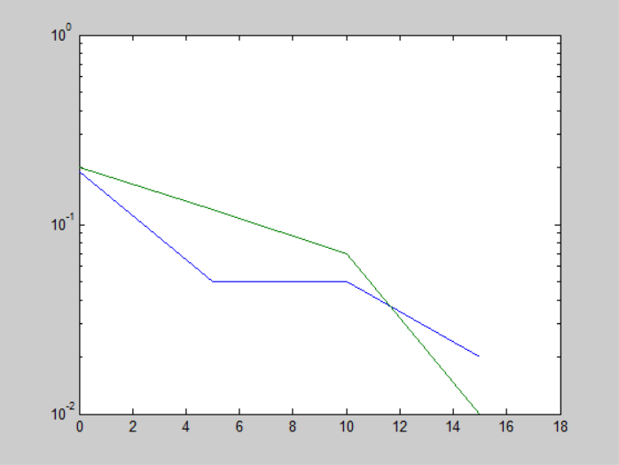

Figure 28 Space-Time coding semiology 2

X axis is signal condition over noise increments, Y axis is BER (Bit Error Rate)

In this simulation implementation, I explored the application of Space-time coding as a coding technique for signal transmission, to know the best-cast transmission architecture to achieve a healthier reflection path and a reduction in interference ahead of time.

I will be covering the two scenarios at stages of the implementation of S-T codes, the receiver knows the configuration of the transmitter after transmission of redundant data through a SISO (Single Input Single Output) system, and its signal receptive quality when it doesn’t know the configuration. Through the first-time observations from sending data, the receiver does not know the configuration of the transmitter and its channels, so we estimate the signal values from this. We then combine and decode the signal data at the receiver to know the signal data and transmission configuration. Then make the rough estimations on the signal to first time detect channel data values at receiver and conditionalize these prior estimate values, to decide a refined estimation value of transmission data. We then check the errors made using the same logic as the previous tasks, but conditionalizing on the two-time slots of the transmission through its mapped path across space and time.

As depicted in the above figure, I surmise that there is a substantial coding gain from this method of coding the redundant data, for the receiver to know transmitter configuration after the first time send. The first summation without coding knowledge of transmission, trends gradually in bit error rate increments over signal to noise increments but drops significantly at 10dBA of interference on the signal with a significant increase in bit error per second. Whilst the second summation trend of coded with knowledge of transmission shows a steeper increase in bit error rate through increasing noise affecting the signal, but levels out at approximately 4.3dBA with a slight reduction in bit error rate. However, it does eventually decline at 10dBA of interference but with a more gradual descent of signal quality in comparison to the first summation. This outcome will be due to the best-case scenario for decoding from the redundant codes that were sent and surmised in the second transmission from the second trend.

Observations from the first time sending of channel data:

***Y1 = h1 coded channel * signal time slot 1 + h2 coded channel * signal time slot 2 + n1 channel***

***Y2 = h1 * s2 + h2 * (-s1) + n2 channel***

Combine the signal data at receiver:

***Xs1 = h1 * y1 – h2 * y2***

***Xs2 = h2 * y1 + h1 * y2***

Make rough estimation on channel data:

***Rough prior estimation 1 = Xs1 / (h1 ^ 2 + h2 ^ 2) First step of detection***

***Rough prior estimation 2 = Xs2 / (h1 ^ 2 + h2 ^ 2) First step of detection***

I refine the estimation using the same conditionalization as the previous modulation task in which prior rough estimate values are checked, to decide refined estimates along the sub sections of data modulation scheme -3 to 3.

***Estimation = y1/(Z) Sign y / (Z)***

***If Z > 2 then estimation = 3***

***Else if Z < 2 and Z > 0 then estimation = 1***

Then check errors made from transmission across the time slot mapping of signals:

***If estimation 1 is not equal to signal time slot 1***

***Then Summation 1 = summation 1 + 1***

***If estimation 2 is not equal to signal time slot 2***

***Then Summation 2 = summation 2 + 1***

Method of simplifying the combining, decoding of signals, workings out:

***y1 = h1 s1 + h2 s2***

***y2 = h1 s2 – h2 s1 =***

***a = b x + c y***

***d = b y – c x***

***b x + c y = a x b =***

***b y – c x = d x c***

***y = b2x + bcy = ab***

***bcy – c2x = cd***

***b2x + c2x = ab – cd***

***(b2 + c2) x = ab – cd***

***(h12 + h22) S1 =***

***h1 * y1 – h2 * y2***

***h12s1 + h1 h2 S2 –***

***(h2 h1 S2 – h12S) = (h12 + h22) S***

***h2 y1 + h1 y2 = h2 h1 s1 + h22 S2 + h12 S2 – h1 h2 s1 = (h12 + h22) S2***

*Denoted by:*

*h1, h2, h (Channels), s1, s2, s (Time-slots), y1, y2 (Observation outcome), b, c, x, d, a (Channel representative variables)*

Key values recorded and evaluated through Space-Time coding simulation:

***Y1 observation value : 2.4766***

***Y2 observation value : –1.1353***

***H1 channel value : 0.6174***

***H2 channel value : -0.2276***

***Prior estimate : 1 2.9344***

***Prior estimate : 2 –2.9208***

***Estimate 1 & 2 : 3, -3***

***Summation value 1 : 1***

***Summation value 2 : 1***

**4.5 Table of Terminology**

|  |  |
| --- | --- |
| **Terminology abbreviates** | **Expansion** |
| MRC | Maximal Ratio Combining |
| EGC | Equal Gain Combining |
| S-T | Space-Time Codes |
| SISO | Single Input Single Output |
| MIMO | Multiple Input Multiple Output |
| FDMA | Frequency Division Multiple Access |
| FDM | Frequency Division Multiplexing |
| TDMA | Time Division Multiple Access |
| TDM | Time Division Multiplexing |
| CDMA | Code Division Multiple Access |
| CDM | Code Division Multiplexing |
| MISO | Multiple Input Single Output |
| SIMO | Single Input Multiple Output |
| SNR | Signal to Noise Ratio |
| NOMA | Non-orthogonal Multiple Access |
| OFDMA | Orthogonal Frequency Division Multiple Access |
| OFDM | Orthogonal Frequency Division Multiplexing |
| OMA | Orthogonal Multiple Access |
| MUST | Multiuser Super-Position Transmission |
| BS | Base Station |
| Tx | Transmitter |
| Rx | Receiver |

**4.6 Summary of implementation and evaluation**

In this chapter I explored the implementation of simulating the outcome of a range of methods of transmission and multiple access expansion. I evaluated and analyzed the errors made on the signals in each of the component cases of transmission systems, the rough and refined estimates of channel data at the receiver, and the summation of this data depicted through semiology vectors. I found that the method of multiple input multiple output antenna provided a substantial array gain of transmission bandwidth, but was proportionate to the number of antennas used in comparison to the first simulation. Also, I inferred, that Space-time coding is a simple but powerful technique for coding transmission data for best-case transmission, which I surmised through the second sending of redundant data which was more reliable than the summation made of first transmission, observed in the relevant semiology. I also found that MRC signal combining for error correction is a more effective alternative to EGC error correction.

**Chapter 5: Conclusion of Future Actions**

In conclusion, this report set out to rationalize, explore and implement/evaluate the varying methods of single/multiple antenna transmission, their range of access methods and the conditions in which a signal is transmitted/received through its path and effectively preventing/correcting these natural interferences.

I was successful in rationalizing and evaluating the spectral efficiency and capacitive limitation of single antenna transmission and their error rates in ratio of signal to noise, in comparison to Multiple antenna transmissions widely utilized in a modern age. It effectively simulated implementation of EGC and MRC combining technique summations for MIMO simulation to increase reliability.

I was also successful in rationalizing and evaluating the bit error rates over noise increments from a modulated signals data and multiple access system through a sub-carrier, in combination with MIMO antenna systems for multiplexing gain. I was similarly successful in rationalizing and evaluating the coding technique of Space-time codes, in which the method showed, that sending redundant data for the best transmission architecture and pathing case of the signal, is an important technique and this applies it simply and powerfully. It is shown in the implementation that coding the data reduces the error rate through noise interference because of channel condition knowledge, and so is an effective method in comparison to first time send.

As a whole the project and this report, presented and explored a multitude of transmission technologies and multiple access techniques, to increase the spectral efficiency, reliability, quality and capacity of channels. I discovered throughout the project that the combination of a multi-antenna system with a multiple access division technique along with an appropriate coding technique such as Space-Time coding, provides an effective reduction in BER per second over interference and increase in capacity/data rate that a transmission can send per second.

If I was to explore the project again, I would look further into NOMA access technique methods and SIC procedures, and attempt to analyze and iterate on that current advanced technology. To be able to effectively rationalize and evaluate work done throughout this project, I had to learn the observation steps and method of each technique/form of transmission, how to apply and translate this logic to coding the programs for the MATHLAB simulations. I learnt through doing this project, the logic behind these methods of transmission/access and the thorough approach to effectively evaluating these methods. I successfully reached the aims of the report and project, in which to explore complex signal transmission methods and formulate an implementation and evaluation of the results from each method through a MATHLAB environment program. I would revise in the future, the Space-Time coding implementation/design to evaluate further components within the coding technique and visualize this in the semiology’s. I would research as future work on access techniques, that provide a low-latency and high data rate improvement. I learnt an appreciation for researchers in this field, as to work involved the complexity of theorizing/practicing these technologies.

Overall, I believe the project went well, I feel I executed the necessary research, implementation/evaluation of these technologies strengths and weaknesses effectively considering the tradeoff of between these methods. I also feel that I’ve learnt a great deal of this area’s work from performing and reviewing this project.

References:

1. *[* [*https://en.wikipedia.org/wiki/Additive_white_Gaussian_noise*](https://en.wikipedia.org/wiki/Additive_white_Gaussian_noise) *:] Tshuva (2015) Additive white Gaussian noise, Online Publication,* [*https://en.wikipedia.org/wiki/Additive_white_Gaussian_noise*](https://en.wikipedia.org/wiki/Additive_white_Gaussian_noise)*, Last Accessed: 30/03/2017*
2. *[* [*https://www.google.co.uk/search?q=multiple+input+multiple+output&client=firefox-b-ab&source=lnms&tbm=isch&sa=X&sqi=2&ved=0ahUKEwjl2q-J6P_SAhXkLMAKHXTmCW8Q_AUIBygC&biw=1920&bih=947#imgrc=IG9wYgd8HzNJQM*](https://www.google.co.uk/search?q=multiple+input+multiple+output&client=firefox-b-ab&source=lnms&tbm=isch&sa=X&sqi=2&ved=0ahUKEwjl2q-J6P_SAhXkLMAKHXTmCW8Q_AUIBygC&biw=1920&bih=947#imgrc=IG9wYgd8HzNJQM)*:] Multiple input Multiple output antenna system, Online image.*
3. *[* [*https://arxiv.org/ftp/arxiv/papers/0909/0909.3342.pdf*](https://arxiv.org/ftp/arxiv/papers/0909/0909.3342.pdf) *:] Manar Mohaisen. YuPeng Wang. KyungHi Chang (2009) Multiple Antenna Technologies, Online Publication, The Graduate School of Information Technology and Telecommunications INHA University,* [*https://arxiv.org/ftp/arxiv/papers/0909/0909.3342.pdf*](https://arxiv.org/ftp/arxiv/papers/0909/0909.3342.pdf)*, Last Accessed: 30/03/2017*
4. *[* [*http://www.gaussianwaves.com/2014/08/mimo-diversity-and-spatial-multiplexing/*](http://www.gaussianwaves.com/2014/08/mimo-diversity-and-spatial-multiplexing/)*,* [*https://en.wikipedia.org/wiki/Spatial_multiplexing*](https://en.wikipedia.org/wiki/Spatial_multiplexing) *:] Mathuranathan (2014) MIMO – Diversity and Spatial Multiplexing, Widefox (2016) Spatial Multiplexing, Online Publications,* [*http://www.gaussianwaves.com/2014/08/mimo-diversity-and-spatial-multiplexing/*](http://www.gaussianwaves.com/2014/08/mimo-diversity-and-spatial-multiplexing/)*,* [*https://en.wikipedia.org/wiki/Spatial_multiplexing*](https://en.wikipedia.org/wiki/Spatial_multiplexing)*, Last Accessed: 30/03/2017*
5. *[* [*https://en.wikipedia.org/wiki/Time_diversity*](https://en.wikipedia.org/wiki/Time_diversity) *:] Joe Decker (2007) Time Diversity, Online Publication,* [*https://en.wikipedia.org/wiki/Time_diversity*](https://en.wikipedia.org/wiki/Time_diversity)*, Last Accessed: 30/03/2017*
6. *[* [*https://en.wikipedia.org/wiki/Forward_error_correction*](https://en.wikipedia.org/wiki/Forward_error_correction) *:] Materialscientist. (2017) Forward error correction, Online Publication,* [*https://en.wikipedia.org/wiki/Forward_error_correction*](https://en.wikipedia.org/wiki/Forward_error_correction)*, Last Accessed: 30/03/2017*
7. *[* [*https://en.wikipedia.org/wiki/Diversity_scheme*](https://en.wikipedia.org/wiki/Diversity_scheme) *:] Chetvorno (2015) Diversity Scheme, Online Publication,* [*https://en.wikipedia.org/wiki/Diversity_scheme*](https://en.wikipedia.org/wiki/Diversity_scheme)*, Last Accessed: 30/03/2017*
8. *[* [*https://en.wikipedia.org/wiki/Diversity_combining*](https://en.wikipedia.org/wiki/Diversity_combining) *:] Edward (2014) Diversity Combining, Online Publication,* [*https://en.wikipedia.org/wiki/Diversity_combining*](https://en.wikipedia.org/wiki/Diversity_combining)*, Last Accessed: 30/03/2017*

  
9. *[* [*https://en.wikipedia.org/wiki/Beamforming*](https://en.wikipedia.org/wiki/Beamforming) *:]* [*Žikica Milošević*](https://en.wikipedia.org/wiki/User:%C5%BDikica_Milo%C5%A1evi%C4%87) *(2017) Beamforming, Online Publication,* [*https://en.wikipedia.org/wiki/Beamforming*](https://en.wikipedia.org/wiki/Beamforming)*, Last Accessed: 30/03/2017*
10. *[* [*https://en.wikipedia.org/wiki/Maximal-ratio_combining*](https://en.wikipedia.org/wiki/Maximal-ratio_combining) *:] John (2013) Maximal-ratio combining, Online Publication,* [*https://en.wikipedia.org/wiki/Maximal-ratio_combining*](https://en.wikipedia.org/wiki/Maximal-ratio_combining)*, Last Accessed: 30/03/2017*
11. *[* [*https://www.google.co.uk/search?q=egc+system&client=firefox-b-ab&source=lnms&tbm=isch&sa=X&ved=0ahUKEwijg4zi7P_SAhWdHsAKHTKJCWEQ_AUIBygC&biw=1920&bih=947#tbm=isch&q=maximal+ratio+combining&*&imgrc=KftpgTCil6DmeM*](https://www.google.co.uk/search?q=egc+system&client=firefox-b-ab&source=lnms&tbm=isch&sa=X&ved=0ahUKEwijg4zi7P_SAhWdHsAKHTKJCWEQ_AUIBygC&biw=1920&bih=947#tbm=isch&q=maximal+ratio+combining&*&imgrc=KftpgTCil6DmeM)*:] MRC configuration, Online image.*
12. *[* [*https://www.google.co.uk/search?q=egc+system&client=firefox-b-ab&source=lnms&tbm=isch&sa=X&ved=0ahUKEwijg4zi7P_SAhWdHsAKHTKJCWEQ_AUIBygC&biw=1920&bih=947#tbm=isch&q=equal+gain+combining&*&imgrc=97if00dFulSUeM*](https://www.google.co.uk/search?q=egc+system&client=firefox-b-ab&source=lnms&tbm=isch&sa=X&ved=0ahUKEwijg4zi7P_SAhWdHsAKHTKJCWEQ_AUIBygC&biw=1920&bih=947#tbm=isch&q=equal+gain+combining&*&imgrc=97if00dFulSUeM)*:] EGC configuration, Online image.*
13. *[* [*https://en.wikipedia.org/wiki/Frequency-division_multiple_access*](https://en.wikipedia.org/wiki/Frequency-division_multiple_access) *:] Joe Decker (2013) Frequency-division multiple access, Online Publication,* [*https://en.wikipedia.org/wiki/Frequency-division_multiple_access*](https://en.wikipedia.org/wiki/Frequency-division_multiple_access)*, Last Accessed: 30/03/2017*
14. *[* [*https://www.google.co.uk/search?q=multiple+access+methods&client=firefox-b-ab&source=lnms&tbm=isch&sa=X&ved=0ahUKEwiC04fC5__SAhXICMAKHdfCBqoQ_AUICCgB&biw=1920&bih=947#imgrc=m9p2TiOlDOLD0M*](https://www.google.co.uk/search?q=multiple+access+methods&client=firefox-b-ab&source=lnms&tbm=isch&sa=X&ved=0ahUKEwiC04fC5__SAhXICMAKHdfCBqoQ_AUICCgB&biw=1920&bih=947#imgrc=m9p2TiOlDOLD0M)*:] FDMA, TDMA and CDMA access technique visualizations, Online Image.*

   
15. *[* [*https://en.wikipedia.org/wiki/Time_division_multiple_access*](https://en.wikipedia.org/wiki/Time_division_multiple_access) *:] Guy Harris (2016) Time division multiple access, Online Publication,* [*https://en.wikipedia.org/wiki/Time_division_multiple_access*](https://en.wikipedia.org/wiki/Time_division_multiple_access)*, Last Accessed: 30/03/2017*
16. *[* [*https://www.google.co.uk/search?q=multiple+access+methods&client=firefox-b-ab&source=lnms&tbm=isch&sa=X&ved=0ahUKEwiC04fC5__SAhXICMAKHdfCBqoQ_AUICCgB&biw=1920&bih=947#imgrc=m9p2TiOlDOLD0M*](https://www.google.co.uk/search?q=multiple+access+methods&client=firefox-b-ab&source=lnms&tbm=isch&sa=X&ved=0ahUKEwiC04fC5__SAhXICMAKHdfCBqoQ_AUICCgB&biw=1920&bih=947#imgrc=m9p2TiOlDOLD0M)*:] FDMA, TDMA and CDMA access technique visualizations, Online image.*
17. *[* [*https://en.wikipedia.org/wiki/Code_division_multiple_access*](https://en.wikipedia.org/wiki/Code_division_multiple_access) *:] Guy Harris (2016) Code division multiple access, Online Publication,* [*https://en.wikipedia.org/wiki/Code_division_multiple_access*](https://en.wikipedia.org/wiki/Code_division_multiple_access)*, Last Accessed: 30/03/2017*
18. *[* [*https://www.google.co.uk/search?q=multiple+access+methods&client=firefox-b-ab&source=lnms&tbm=isch&sa=X&ved=0ahUKEwiC04fC5__SAhXICMAKHdfCBqoQ_AUICCgB&biw=1920&bih=947#imgrc=m9p2TiOlDOLD0M*](https://www.google.co.uk/search?q=multiple+access+methods&client=firefox-b-ab&source=lnms&tbm=isch&sa=X&ved=0ahUKEwiC04fC5__SAhXICMAKHdfCBqoQ_AUICCgB&biw=1920&bih=947#imgrc=m9p2TiOlDOLD0M)*:] FDMA, TDMA and CDMA access technique visualizations, Online image.*
19. *[* [*https://en.wikipedia.org/wiki/Orthogonal_frequency-division_multiplexing*](https://en.wikipedia.org/wiki/Orthogonal_frequency-division_multiplexing) *:] Richi (2017) Orthogonal frequency-division multiplexing, Online Publication,* [*https://en.wikipedia.org/wiki/Orthogonal_frequency-division_multiplexing*](https://en.wikipedia.org/wiki/Orthogonal_frequency-division_multiplexing)*, Last Accessed: 30/03/2017*
20. *[*[*https://www.google.co.uk/search?q=orthogonal+frequency+division+multiplexing&client=firefox-b-ab&source=lnms&tbm=isch&sa=X&ved=0ahUKEwjOp-Dk7f_SAhUICsAKHTRYCRgQ_AUICCgB&biw=1920&bih=947#tbm=isch&q=orthogonal+frequency+division+ifft&*&imgrc=ad41dvzWmUA4PM*](https://www.google.co.uk/search?q=orthogonal+frequency+division+multiplexing&client=firefox-b-ab&source=lnms&tbm=isch&sa=X&ved=0ahUKEwjOp-Dk7f_SAhUICsAKHTRYCRgQ_AUICCgB&biw=1920&bih=947#tbm=isch&q=orthogonal+frequency+division+ifft&*&imgrc=ad41dvzWmUA4PM)*:] OFDM visualization, Online image.*
21. *[* [*https://en.wikipedia.org/wiki/Orthogonal_frequency-division_multiple_access*](https://en.wikipedia.org/wiki/Orthogonal_frequency-division_multiple_access) *:] Chenzw (2016) Orthogonal frequency-division multiple access, Online Publication,* [*https://en.wikipedia.org/wiki/Orthogonal_frequency-division_multiple_access*](https://en.wikipedia.org/wiki/Orthogonal_frequency-division_multiple_access)*, Last Accessed: 30/03/2017*
22. *[*[*https://www.google.co.uk/search?q=orthogonal+frequency+division+multiplexing&client=firefox-b-ab&source=lnms&tbm=isch&sa=X&ved=0ahUKEwjOp-Dk7f_SAhUICsAKHTRYCRgQ_AUICCgB&biw=1920&bih=947#tbm=isch&q=orthogonal+frequency+division+multiple+access&*&imgrc=W8vx-1CrAMX7XM*](https://www.google.co.uk/search?q=orthogonal+frequency+division+multiplexing&client=firefox-b-ab&source=lnms&tbm=isch&sa=X&ved=0ahUKEwjOp-Dk7f_SAhUICsAKHTRYCRgQ_AUICCgB&biw=1920&bih=947#tbm=isch&q=orthogonal+frequency+division+multiple+access&*&imgrc=W8vx-1CrAMX7XM)*:] OFDMA visualization, Online image.*
23. *[* [*https://arxiv.org/pdf/1511.08610.pdf*](https://arxiv.org/pdf/1511.08610.pdf) *:] Zhiguo Ding. Yuanwei Liu. Jinho Choi. Qi Sun. Maged Elkashlan. Chih-Lin I and H. Vincent Poor (2016) Application of Non-Orthogonal Multiple Access in LTE and 5G Networks, Online Publication, School of Computing and Communications, Lancaster University, School of the Electronic Engineering and Computer Science, Queen Mary University of London,* [*https://arxiv.org/pdf/1511.08610.pdf*](https://arxiv.org/pdf/1511.08610.pdf)*, Last Accessed: 30/03/2017*
24. *[* [*https://arxiv.org/pdf/1511.08610.pdf*](https://arxiv.org/pdf/1511.08610.pdf) *:] Zhiguo Ding. Yuanwei Liu. Jinho Choi. Qi Sun. Maged Elkashlan. Chih-Lin I and H. Vincent Poor (2016) Application of Non-Orthogonal Multiple Access in LTE and 5G Networks, Online Publication, School of Computing and Communications, Lancaster University, School of the Electronic Engineering and Computer Science, Queen Mary University of London,* [*https://arxiv.org/pdf/1511.08610.pdf*](https://arxiv.org/pdf/1511.08610.pdf)*, Last Accessed: 30/03/2017*
25. *[* [*https://arxiv.org/pdf/1511.08610.pdf*](https://arxiv.org/pdf/1511.08610.pdf) *:] Zhiguo Ding. Yuanwei Liu. Jinho Choi. Qi Sun. Maged Elkashlan. Chih-Lin I and H. Vincent Poor (2016) Application of Non-Orthogonal Multiple Access in LTE and 5G Networks, Online image within publication, School of Computing and Communications, Lancaster University, School of the Electronic Engineering and Computer Science, Queen Mary University of London,* [*https://arxiv.org/pdf/1511.08610.pdf*](https://arxiv.org/pdf/1511.08610.pdf)*, Last Accessed: 30/03/2017*
26. *[* [*https://en.wikipedia.org/wiki/Fading*](https://en.wikipedia.org/wiki/Fading) *:] Jim Henderson (2017) Fading, Online Publication,* [*https://en.wikipedia.org/wiki/Fading*](https://en.wikipedia.org/wiki/Fading)*, Last Accessed: 30/03/2017*
27. *[* [*https://www.google.co.uk/search?q=time+selective+channels&client=firefox-b-ab&source=lnms&tbm=isch&sa=X&ved=0ahUKEwj5jLyc8f_SAhWJAsAKHYgVDfcQ_AUICSgC&biw=1920&bih=947#tbm=isch&q=time+selective+and+frequency+selective+channels&*&imgrc=HdPuXqe50J2FqM*](https://www.google.co.uk/search?q=time+selective+channels&client=firefox-b-ab&source=lnms&tbm=isch&sa=X&ved=0ahUKEwj5jLyc8f_SAhWJAsAKHYgVDfcQ_AUICSgC&biw=1920&bih=947#tbm=isch&q=time+selective+and+frequency+selective+channels&*&imgrc=HdPuXqe50J2FqM) *:] Time selective and Frequency selective channels, Online image.*
28. *[* [*http://ieeexplore.ieee.org/stamp/stamp.jsp?tp=&arnumber=4470104*](http://ieeexplore.ieee.org/stamp/stamp.jsp?tp=&arnumber=4470104) *:] N. Wei. T. C. Li. S. Y. Yang. S.G Zhang. S.J Ding (2008) A New Space-Time-Doppler Code for Time-Selective Fading Channels, College of Information and Communication Engineering Harbin Engineering University, Harbin Heilongjiang 150001, China, China Research Institute of Radiowave Propagation, Qingdao Shandong 266107,* [*http://ieeexplore.ieee.org/stamp/stamp.jsp?tp=&arnumber=4470104*](http://ieeexplore.ieee.org/stamp/stamp.jsp?tp=&arnumber=4470104)*, Last Accessed 31/03/2017*
29. *[* [*https://www.google.co.uk/search?q=frequency+flat+channel&client=firefox-b-ab&source=lnms&tbm=isch&sa=X&ved=0ahUKEwi_6c7_8f_SAhULJ8AKHVPnDQAQ_AUICCgB&biw=1920&bih=947#tbm=isch&q=frequency+flat+signal&*&imgrc=VF1DD13E_4C0FM*](https://www.google.co.uk/search?q=frequency+flat+channel&client=firefox-b-ab&source=lnms&tbm=isch&sa=X&ved=0ahUKEwi_6c7_8f_SAhULJ8AKHVPnDQAQ_AUICCgB&biw=1920&bih=947#tbm=isch&q=frequency+flat+signal&*&imgrc=VF1DD13E_4C0FM) *:] Frequency-flat and non-flat signal, Online image.*
30. *[* [*http://web.stanford.edu/group/sarg/sandhu062503.pdf*](http://web.stanford.edu/group/sarg/sandhu062503.pdf) *:] Sumeet Sandhu. Rohit Nabar. Dhananjay Gore. and Arogyaswami Paulraj (2003) Introduction to Space-Time Codes, Online Publication, Intel Corporation, M/S RNB 6-49, Smart Antennas Research Group,* [*http://web.stanford.edu/group/sarg/sandhu062503.pdf*](http://web.stanford.edu/group/sarg/sandhu062503.pdf)*, Last Accessed: 30/03/2017*
31. *[* [*http://web.stanford.edu/group/sarg/sandhu062503.pdf*](http://web.stanford.edu/group/sarg/sandhu062503.pdf) *:] Sumeet Sandhu. Rohit Nabar. Dhananjay Gore. and Arogyaswami Paulraj (2003) Introduction to Space-Time Codes, Online Publication, Intel Corporation, M/S RNB 6-49, Smart Antennas Research Group* [*http://web.stanford.edu/group/sarg/sandhu062503.pdf*](http://web.stanford.edu/group/sarg/sandhu062503.pdf)*, Last Accessed: 30/03/2017*
32. *[* [*https://arxiv.org/ftp/arxiv/papers/0909/0909.3342.pdf*](https://arxiv.org/ftp/arxiv/papers/0909/0909.3342.pdf) *:] Manar Mohaisen. YuPeng Wang. KyungHi Chang (2009) Multiple Antenna Technologies, Online image within publication, The Graduate School of Information Technology and Telecommunications INHA University,* [*https://arxiv.org/ftp/arxiv/papers/0909/0909.3342.pdf*](https://arxiv.org/ftp/arxiv/papers/0909/0909.3342.pdf)*, Last Accessed: 30/03/2017*